Tomato Spinach Chicken Spaghetti
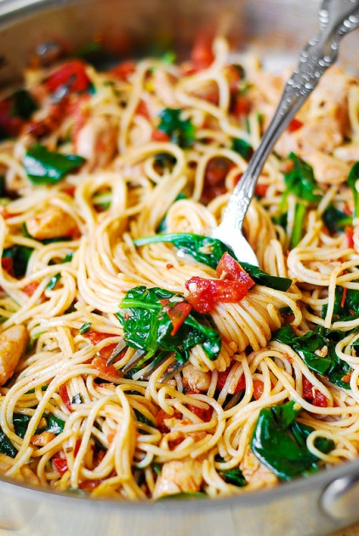
Prep Time 20 min Cook Time 40 min
4 servings

Ingredients
¼ cup sun-dried tomatoes chopped
2 Tbsp olive oil drained from sun-dried tomatoes
½ lb chicken boneless and skinless
¼ tsp salt
¼ tsp red pepper flakes
4 Roma tomatoes chopped
¼ cup fresh basil leaves chopped
8 oz spinach fresh
3 garlic cloves chopped
8 oz spaghetti

Directions
- Cook 2 ounces of pasta per serving according to package directions, until al dente if serving immediately.
- Add chopped sun-dried tomatoes and 2 tablespoons of sun-dried tomato oil to large skillet with lid on medium-low heat. Add chopped chicken, red pepper flakes, and salt over all of the ingredients in the skillet and cook on medium heat until chicken is cooked through and no longer pink, about 5 minutes.
- Add tomatoes, basil leaves, and garlic to the skillet with chicken. Slowly fold spinach into the skillet. Cook on medium heat about 3 to 5 minutes until spinach wilts just a little, and tomatoes release some of their juices. Remove from heat. Cover with lid and keep off heat.
- Separate sauce into two portions, one to freeze and one to eat.
- Add pasta to the skillet with the chicken and vegetables. Reheat on low heat, mix everything well. Remove from heat.
- Add more sun-dried tomato oil if desired.

